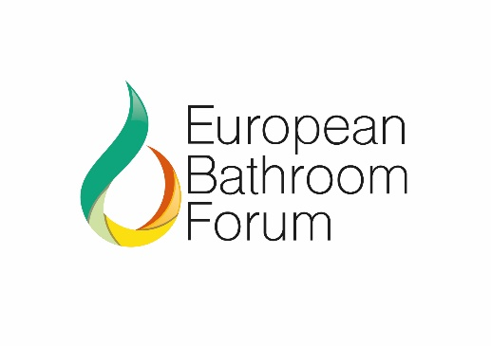
June 2020

NON-DISCLOSURE AGREEMENT

The European Bathroom Forum seeks a Voluntary Agreement (VA) focussed on the voluntary Industry initiative for labelling taps and showers sold within the European market. Any VA awarded attracts a 9 step criteria of which one is market representation. The Unified Water Label looks to represent 80% of units sold across Europe – 1 of the VA criteria with a target date of March 202I.
However, the 80% representation must be independently verified and as such the Unified Water Label has engaged the services of RSM Global, their UK division, to collate, consolidate and issue an annual report to DG Env as evidence of representation, market growth and identify areas of improvement to the collation process.
To drive manufacturers confidence in the confidentiality of this process RSM has produced a Non-Disclosure Agreement, which can if necessary be issued on a one to one company basis signed by RSM. A copy of this Agreement is attached.
Any company seeking an individually signed Agreement should contact Philip Jackson at RSM on Philip.jackson@rsmuk.com
It is important and a vital element in the journey to a VA that all registered companies submit to RSM their data in respect of market share.
If you have any queries regarding the NDA or submission of data please do not hesitate in contacting Philip Jackson or myself.

YVONNE ORGILL
MD
UNIFIED WATER LABEL
Mobile: 07980600446

